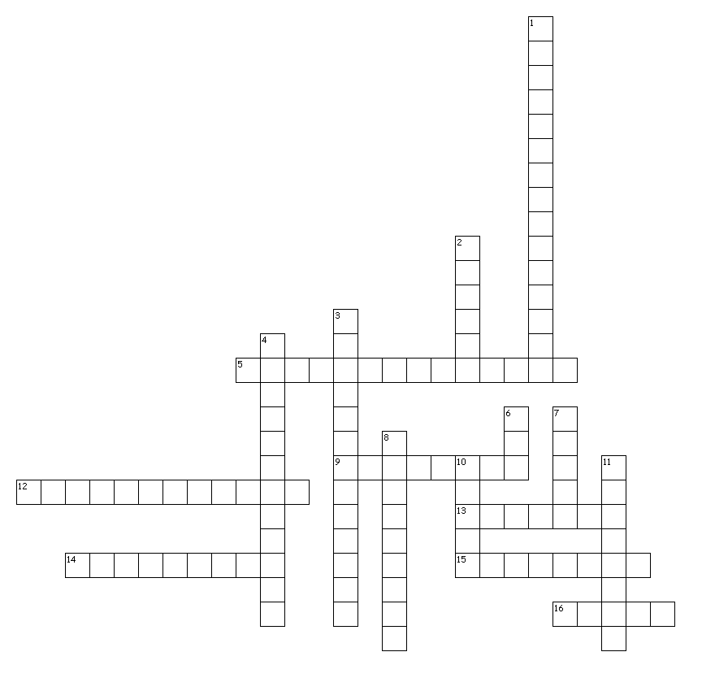
Literary Devices
Down
Across
5. a detail highlighted to give sense of humor or sarcasm
9. author makes a reference to another literary work
12. words with the same letter/sound
13. details used to paint a picture in the reader's mind
14. extreme exaggeration
15. comparing two things without like or as
16. unexpected, surprising

1. giving nonhuman things human characteristics
2. comparing two things using like or as
3. clues given to predict what's coming next
4. words for sounds like BOOM!
6. play on words, two suggested meanings
7. message given about life
8. interruption in the story to tell about an event from the past
10. a phrase not meant to be taken literal, used for description
11. opposite words beside each other used for emphasis

