Name: __________

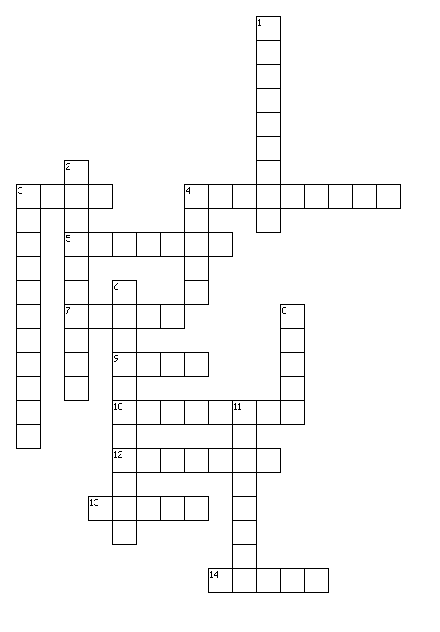
Characters and their Perspective

Use the following clues to fill in the blanks.

Across
3. the plan, sequence of events in a story
4. conclusion drawn from prior knowledge
5. events created by the imagination
7. a story's message or insight to life
9. how the author feels about the subject
10. group or person for whom selection is written/performed
12. details used to paint a picture in the reader's mind
13. category used to classify literature
14. written work meant to be read aloud

Down
1. the people or animals in the story
2. true events, facts
3. the way a character views a situation
4. surprising or amusing contradiction
6. main ideas in a literary work
8. a division of an act in a play
11. person telling the story

